**VISVESVARAYA TECHNOLOGICAL UNIVERSITY**

**“JnanaSangama”, Belgaum -590014, Karnataka.**



**LAB REPORT**

**on**

**Analysis and Design of Algorithms**

***Submitted by***

**VINAYAK Y BAJANTRI (1BM20CS189)**

***in partial fulfillment for the award of the degree of***

**BACHELOR OF ENGINEERING**

***in***

**COMPUTER SCIENCE AND ENGINEERING**



**B.M.S. COLLEGE OF ENGINEERING**

**(Autonomous Institution under VTU)**

**BENGALURU-560019**

**May-2022 to July-2022**

**B. M. S. College of Engineering,**

**Bull Temple Road, Bangalore 560019**

(Affiliated To Visvesvaraya Technological University, Belgaum)

**Department of Computer Science and Engineering**



**CERTIFICATE**

This is to certify that the Lab work entitled “**Analysis and Design of Algorithms**” carried out by  **VINAYAK Y BAJANTRI(1BM20CS189),** who is bonafide student of **B. M. S. College of Engineering.** It is in partial fulfillment for the award of **Bachelor of Engineering in Computer Science and Engineering** of the Visvesvaraya Technological University, Belgaum during the year 2022. The Lab report has been approved as it satisfies the academic requirements in respect of **Analysis and Design of Algorithms - (19CS4PCADA)** work prescribed for the said degree.

Name of the Lab-In charge: Vikranth B N           **Dr. Jyothi S Nayak** Assistant Professor Professor and Head

Department of CSE Department of CSE

BMSCE, Bengaluru BMSCE, Bengaluru

**Index Sheet**

| **Sl. No.** | **Experiment Title** | **Page No.** |
| --- | --- | --- |
| **1** | Write a recursive program to Solve  **a)** Towers-of-Hanoi problem **b)** To find GCD | **5** |
| **2** | Implement Recursive Binary search and Linear search and determine the time required to search an element. Repeat the experiment for different values of N and plot a graph of the time taken versus N. | **7** |
| **3** | Sort a given set of N integer elements using Selection Sort technique and compute its time taken. Run the program for different values of N and record the time taken to sort. | **13** |
| **4** | Write program to do the following:  **a)** Print all the nodes reachable from a given starting node in a digraph using BFS method.  **b)** Check whether a given graph is connected or not using DFS method. | **16** |
| **5** | Sort a given set of N integer elements using Insertion Sort technique and compute its time taken. | **20** |
| **6** | Write program to obtain the Topological ordering of vertices in a given digraph. | **22** |
| **7** | Implement Johnson Trotter algorithm to generate permutations. | **24** |
| **8** | Sort a given set of N integer elements using Merge Sort technique and compute its time taken. Run the program for different values of N and record the time taken to sort. | **29** |
| **9** | Sort a given set of N integer elements using Quick Sort technique and compute its time taken. | **32** |
| **10** | Sort a given set of N integer elements using Heap Sort technique and compute its time taken. |  |
| **11** | Implement Warshall’s algorithm using dynamic programming |  |
| **12** | Implement 0/1 Knapsack problem using dynamic programming. |  |
| **13** | Implement All Pair Shortest paths problem using Floyd’s algorithm. |  |
| **14** | Find Minimum Cost Spanning Tree of a given undirected graph using Prim’s algorithm. |  |
| **15** | Find Minimum Cost Spanning Tree of a given undirected graph using Kruskals algorithm. |  |
| **16** | From a given vertex in a weighted connected graph, find shortest paths to other vertices using Dijkstra’s algorithm. |  |
| **17** | 1. Implement “Sum of Subsets” using Backtracking. “Sum of Subsets” problem: Find a subset of a given set S = {s1,s2,……,sn} of n positive integers whose sum is equal to a given positive integer d. For example, if S = {1,2,5,6,8} and d = 9 there are two solutions {1,2,6} and {1,8}. A suitable message is to be displayed if the given problem instance doesn’t have a solution. |  |
| **18** | Implement “N-Queens Problem” using Backtracking. |  |

**Course Outcome**

| **CO1** | Ability to **analyze** time complexity of Recursive and Non-Recursive algorithms using asymptotic notations. |
| --- | --- |
| **CO2** | Ability to **design** efficient algorithms using various design techniques. |
| **CO3** | Ability to **apply** the knowledge of complexity classes P, NP, and NP-Complete and prove certain problems are NP-Complete |
| **CO4** | Ability to **conduct** practical experiments to solve problems using an appropriate designing method and find time efficiency. |

**Write a recursive program to Solve**

1. **Towers-of-Hanoi problem b) To find GCD**
2. **TOWER OF HANOI**

**#include <stdio.h>**

**void toh(int n,char a,char b,char c)**

**{**

**if(n>0)**

**{**

**toh(n-1,a,c,b);**

**printf("move the disk from %c to %c\n",a,c);**

**toh(n-1,b,a,c);**

**}**

**}**

**int main()**

**{**

**int n;**

**char a,b,c;**

**printf("Enter the number of disks: ");**

**scanf("%d",&n);**

**toh(n,'a','b','c');**

**return 0;**

**}**

**OUTPUT:**

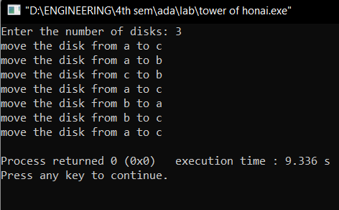

1. **GREATEST COMMON DIVISOR**

**#include <stdio.h>**

**int gcd(int a,int b) {**

**if(b!=0)**

**return gcd(b,a%b);**

**else**

**return a;**

**}**

**void main()**

**{**

**int a,b,c;**

**printf("Enter two numbers: ");**

**scanf("%d %d",&a,&b);**

**c=gcd(a,b);**

**printf("The gcd of two numbers is %d\n",c);**

**}**

**OUTPUT:**

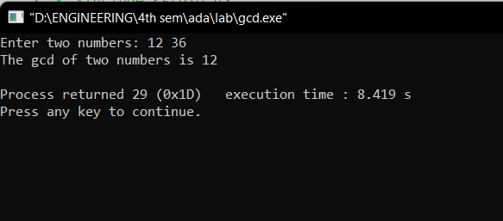

**2.Implement Recursive Binary search and Linear search and determine the time required to search an element. Repeat the experiment for different values of N and plot a graph of the time taken versus N.**

**CODE:**

**#include<stdio.h>;**

**#include<time.h>;**

**#include<stdlib.h>;**

**int bin_srch(int [],int,int,int);**

**int lin_srch(int [],int,int,int);**

**int n,a[1000000];**

**int main() {**

**int ch,key,search_status,temp;**

**clock_t end,start;**

**unsigned long int i, j;**

**while(1) {**

**printf("\n1: Binary search\t 2: Linear search\t 3: Exit\n");**

**printf("\nEnter your choice:\t");**

**scanf("%d",&ch);**

**switch(ch) {**

**case 1:**

**n=1000;**

**while(n<=7000){**

**for(i=0;i<n;i++)**

**a[i]=i;**

**key=a[n-1];**

**start=clock();**

**search_status=bin_srch(a,0,n-1,key);**

**end=clock();**

**if(search_status==-1)**

**printf("\nKey Not Found");**

**else**

**printf("\n Key found at position %d",search_status);**

**printf("\nTime for n=%d is %f Secs",n,(double)(end-**

**start)/CLOCKS_PER_SEC);**

**n=n+1000;**

**}**

**break;**

**case 2:**

**n=1000;**

**while(n<=7000) {**

**for(i=0;i<n;i++)**

**a[i]=i;**

**key=a[n-1];**

**start=clock();**

**search_status=lin_srch(a,0,n-1,key);**

**end=clock();**

**if(search_status==-1)**

**printf("\nKey Not Found");**

**else**

**printf("\n Key found at position %d",search_status);**

**printf("\nTime for n=%d is %f Secs",n,(double)(end-**

**start)/CLOCKS_PER_SEC);**

**n=n+1000;**

**}**

**break;**

**default:**

**exit(0);**

**}**

**getchar();**

**}**

**}**

**int bin_srch(int a[],int low,int high,int key) {**

**for(int j=0;j<1000000;j++);**

**int mid;**

**if(low>high)**

**return -1;**

**mid=(low+high)/2;**

**if(key==a[mid])**

**return mid;**

**if(key<a[mid])**

**return bin_srch(a,low,mid-1,key);**

**else**

**return bin_srch(a,mid+1,high,key);**

**}**

**int lin_srch(int a[],int i,int high,int key) {**

**for(int j=0;j<10000;j++){ int temp=38/600;}**

**if(i>high)**

**return -1;**

**if(key==a[i])**

**return i;**

**else**

**return lin_srch(a,i+1,high,key);**

**}**

**OUTPUT:**

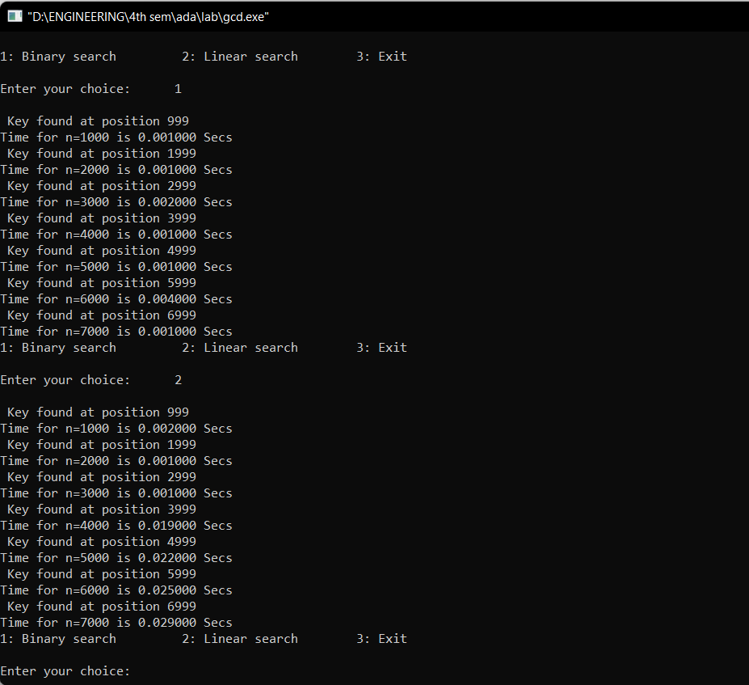

**GRAPH:** 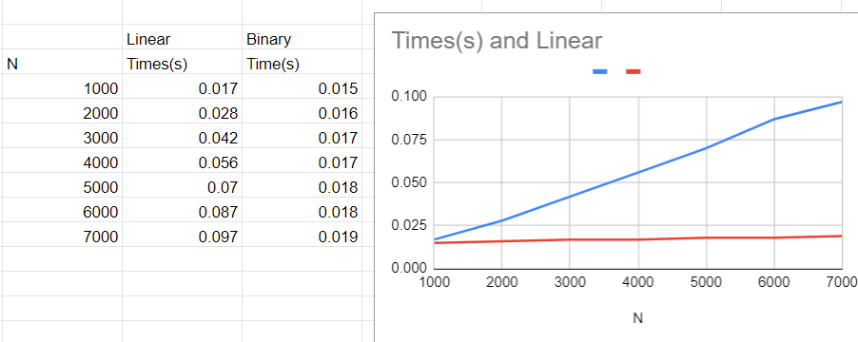

**3.Sort a given set of N integer elements using Selection Sort technique and compute its time taken. Run the program for different values of N and record the time taken to sort.**

**CODE:**

**#include<stdio.h>**

**#include<time.h>**

**void sort(int x){**

**int n=x;**

**int a[n],max,i,j,k;**

**for(i=0;i<n;i++)**

**a[i]=i+1;**

**double start,end;**

**start = clock();**

**for(i=0;i<(n-1);i++){**

**max=a[i];**

**for(j=(i+1);j<n;j++){**

**if(max<a[j]){**

**max=a[j];**

**k=j;**

**}**

**}**

**if(a[i]!=max){**

**int temp=a[i];**

**a[i]=a[k];**

**a[k]=temp;**

**}**

**}**

**end = clock();**

**printf("Time taken to sort %d numbers is %f seconds \n",n,(end-start)/CLOCKS_PER_SEC);**

**n=n+1000;**

**}**

**void main(){**

**for(int x=1000;x<=10000;x+=1000){**

**sort(x);}**

**}**

**OUTPUT:**

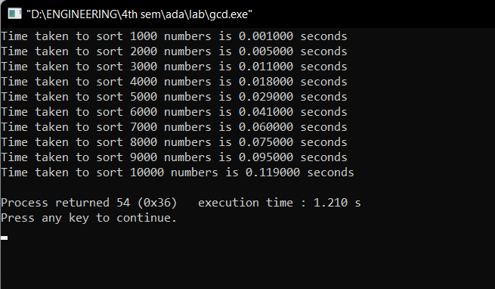

**GRAPH:**

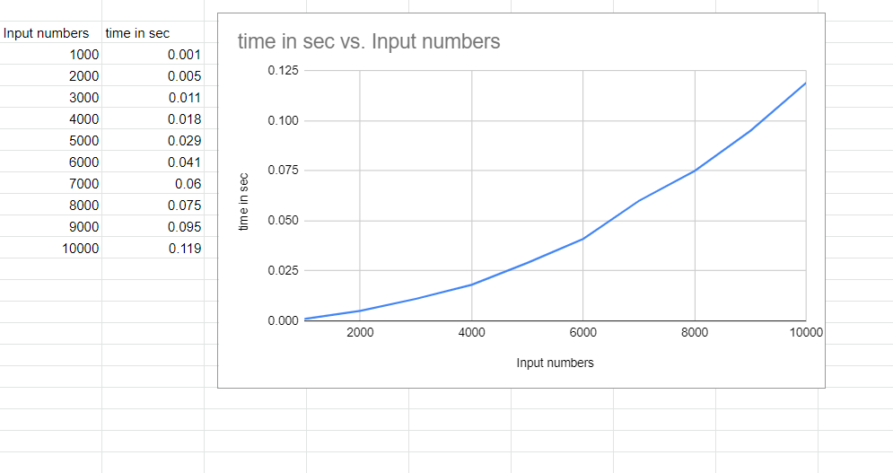

**4.Write program to do the following:**

**a) Print all the nodes reachable from a given starting node in a digraph using BFS method.**

**b) Check whether a given graph is connected or not using DFS method.**

1. **BREADTH FIRST SEARCH**

**CODE:**

**#include<stdio.h>**

**#include<conio.h>**

**int a[15][15],n;**

**void bfs(int);**

**void main() {**

**int i,j,src;**

**printf("\nEnter the no of nodes:\t");**

**scanf("%d",&n);**

**printf("\nEnter the adjacency matrix:\n");**

**for(i=1;i<=n;i++)**

**for(j=1;j<=n;j++)**

**scanf("%d",&a[i][j]);**

**printf("\nEnter the source node:\t");**

**scanf("%d",&src);**

**bfs(src);**

**}**

**void bfs(int src) {**

**int q[15],f=0,r=-1,vis[15],i,j;**

**for(j=1;j<=n;j++)**

**vis[j]=0;**

**vis[src]=1;**

**r=r+1;**

**q[r]=src;**

**while(f<=r) {**

**i=q[f];**

**f=f+1;**

**for(j=1;j<=n;j++)**

**{**

**if(a[i][j]==1&&vis[j]!=1) {**

**vis[j]=1;**

**r=r+1;**

**q[r]=j;**

**}**

**}**

**}**

**for(j=1;j<=n;j++) {**

**if(vis[j]!=1)**

**printf("\nNode %d is not reachable",j);**

**else**

**printf("\nNode %d is reachable",j);**

**}**

**}**

**OUTPUT:**

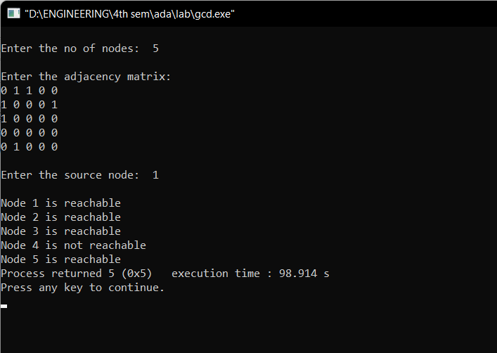

**b)DEPTH FIRST SEARCH**

**CODE:**

**#include<stdio.h>**

**#include<conio.h>**

**int a[10][10],n,vis[10];**

**int dfs(int);**

**void main()**

**{**

**int i,j,src,ans;**

**for(j=1;j<=n;j++)**

**vis[j]=0;**

**printf("\nEnter the no of nodes:\t");**

**scanf("%d",&n);**

**printf("\nEnter the adjacency matrix:\n");**

**for(i=1;i<=n;i++)**

**for(j=1;j<=n;j++)**

**scanf("%d",&a[i][j]);**

**printf("\nEnter the source node:\t");**

**scanf("%d",&src);**

**ans=dfs(src);**

**if(ans==1)**

**printf("\nGraph is connected\n");**

**else**

**printf("\nGragh is not connected\n");**

**getch();**

**}**

**int dfs(int src)**

**{**

**int j;**

**vis[src]=1;**

**for(j=1;j<=n;j++)**

**if(a[src][j]==1&&vis[j]!=1)**

**dfs(j);**

**for(j=1;j<=n;j++) {**

**if(vis[j]!=1)**

**return 0;**

**}**

**return 1;**

**}**

**OUTPUT:**

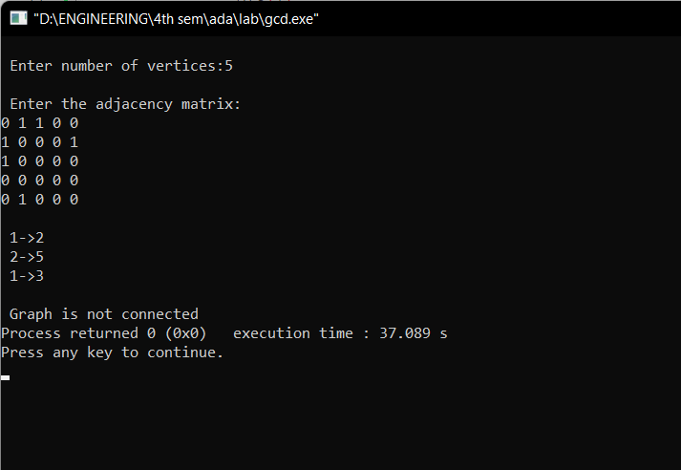

**5.Sort a given set of N integer elements using Insertion Sort technique and compute its time taken.**

**CODE:**

**#include <math.h>**

**#include <stdio.h>**

**#include<stdlib.h>**

**#include<time.h>**

**void insertionSort(int arr[], int n)**

**{**

**int i, key, j;**

**for (i = 1; i < n; i++)**

**{**

**key = arr[i];**

**j = i - 1;**

**while (j >= 0 && arr[j] > key)**

**{**

**for(int k=0;k<100000;k++);**

**arr[j + 1] = arr[j];**

**j = j - -;**

**}**

**arr[j + 1] = key;**

**}**

**}**

**void main() {**

**int i, n;**

**clock_t start, end;**

**printf("ENTER ARRAY SIZE =");**

**scanf("%d", &n);**

**int arr[150000];**

**for (int j = 0; j < n; j++)**

**arr[j] = rand()%10000;**

**for (i = 0; i < n; i++)**

**printf(" %d", arr[i]);**

**printf("\n");**

**start = clock();**

**insertionSort(arr, n);**

**end = clock();**

**printf("\nSorted elements = ");**

**for (i = 0; i < n; i++)**

**printf(" %d", arr[i]);**

**printf("\n Time taken to sort %d Numbers is %f secs", n, (((double)(end - start)) / CLOCKS_PER_SEC));**

**}**

**OUTPUT:**

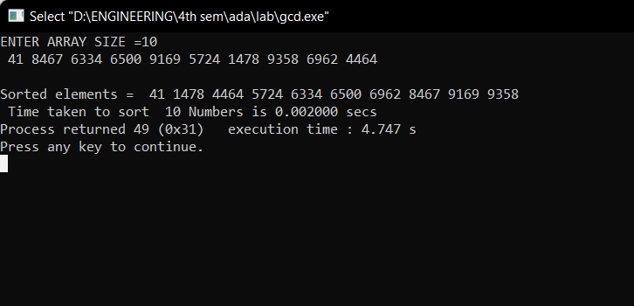

**GRAPH:**

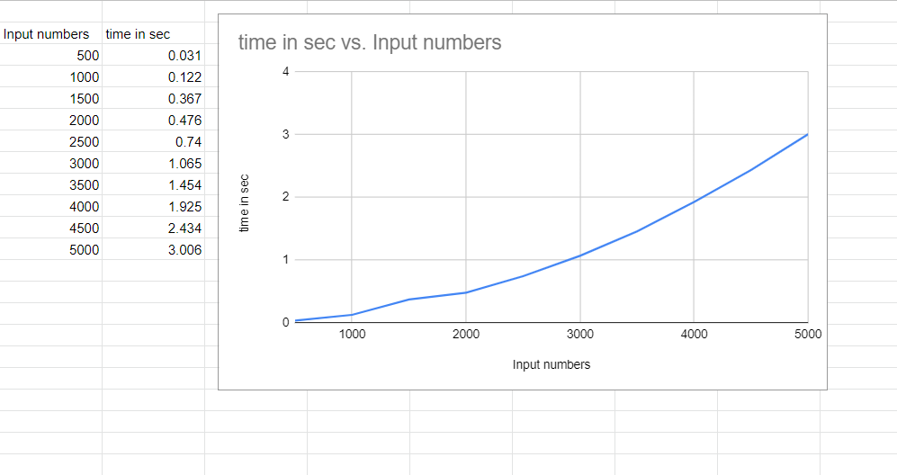

**6.Write program to obtain the Topological ordering of vertices in a given digraph.**

**CODE:**

**#include<stdio.h>**

**#include<conio.h>**

**void source_removal(int n, int a[10][10]) {**

**int i,j,k,u,v,top,s[10],t[10],indeg[10],sum;**

**for(i=0;i<n;i++) {**

**sum=0;**

**for(j=0;j<n;j++)**

**sum+=a[j][i];**

**indeg[i]=sum;**

**}**

**top=-1;**

**for(i=0;i<n;i++) {**

**if(indeg[i]==0)**

**s[++top]=i;**

**}**

**k=0;**

**while(top!=-1) {**

**u=s[top--];**

**t[k++]=u;**

**for(v=0;v<n;v++) {**

**if(a[u][v]==1) {**

**indeg[v]=indeg[v]-1;**

**if(indeg[v]==0)**

**s[++top]=v;**

**}**

**}**

**}**

**printf("Topological order :");**

**for(i=0;i<n;i++)**

**printf(" %d", t[i]);**

**}**

**void main() {**

**int i,j,a[10][10],n;**

**printf("Enter number of nodes\n");**

**scanf("%d", &n);**

**printf("Enter the adjacency matrix\n");**

**for(i=0;i<n;i++)**

**for(j=0;j<n;j++)**

**scanf("%d", &a[i][j]);**

**source_removal(n,a);**

**getch();**

**}**

**OUTPUT:**

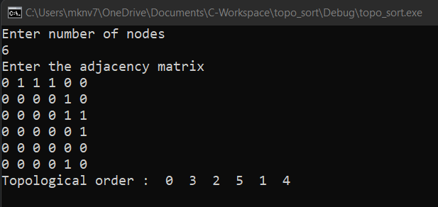

**7.Implement Johnson Trotter algorithm to generate permutations.**

**CODE:**

**#include <stdio.h>**

**#include <stdlib.h>**

**int flag = 0;**

**int swap(int *a,int *b) {**

**int t = *a;**

**\*a = *b;**

**\*b = t;**

**}**

**int search(int arr[],int num,int mobile)**

**{**

**int g;**

**for(g=0;g<num;g++) {**

**if(arr[g] == mobile)**

**return g+1;**

**else**

**flag++;**

**}**

**return -1;**

**}**

**int find_Moblie(int arr[],int d[],int num)**

**{**

**int mobile = 0;**

**int mobile_p = 0;**

**int i;**

**for(i=0;i<num;i++)**

**{**

**if((d[arr[i]-1] == 0) && i != 0)**

**{**

**if(arr[i]>arr[i-1] && arr[i]>mobile_p)**

**{**

**mobile = arr[i];**

**mobile_p = mobile;**

**}**

**else**

**flag++;**

**}**

**else if((d[arr[i]-1] == 1) & i != num-1)**

**{**

**if(arr[i]>arr[i+1] && arr[i]>mobile_p)**

**{**

**mobile = arr[i];**

**mobile_p = mobile;**

**}**

**else**

**flag++;**

**}**

**else**

**flag++;**

**}**

**if((mobile_p == 0) && (mobile == 0))**

**return 0;**

**else**

**return mobile;**

**}**

**void permutations(int arr[],int d[],int num)**

**{**

**int i;**

**int mobile = find_Moblie(arr,d,num);**

**int pos = search(arr,num,mobile);**

**if(d[arr[pos-1]-1]==0)**

**swap(&arr[pos-1],&arr[pos-2]);**

**else**

**swap(&arr[pos-1],&arr[pos]);**

**for(int i=0;i<num;i++)**

**{**

**if(arr[i] > mobile)**

**{**

**if(d[arr[i]-1]==0)**

**d[arr[i]-1] = 1;**

**else**

**d[arr[i]-1] = 0;**

**}**

**}**

**for(i=0;i<num;i++)**

**{**

**printf(" %d ",arr[i]);**

**} }**

**int factorial(int k)**

**{**

**int f = 1;**

**int i = 0;**

**for(i=1;i<k+1;i++)**

**f = f*i;**

**return f;**

**}**

**int main()**

**{**

**int num = 0;**

**int i;**

**int j;**

**int z = 0;**

**printf("Johnson trotter algorithm to find all permutations of given numbers \n");**

**printf("Enter the number\n");**

**scanf("%d",&num);**

**int arr[num],d[num];**

**z = factorial(num);**

**printf("total permutations = %d",z);**

**printf("\nAll possible permutations are: \n");**

**for(i=0;i<num;i++)**

**{**

**d[i] = 0;**

**arr[i] = i+1;**

**printf(" %d ",arr[i]);**

**}**

**printf("\n");**

**for(j=1;j<z;j++) {**

**permutations(arr,d,num);**

**printf("\n");**

**}**

**return 0;**

**}**

**OUTPUT:**

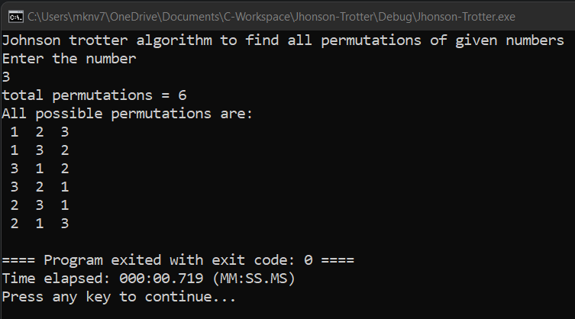

**8.Sort a given set of N integer elements using Merge Sort technique and compute its time taken. Run the program for different values of N and record the time taken to sort.**

**CODE:**

**#include<stdio.h>**

**#include<stdlib.h>**

**#include<time.h>**

**void mergesort(int a[],int i,int j);**

**void merge(int a[],int i1,int j1,int i2,int j2);**

**int main()**

**{**

**clock_t start,end;**

**int a[30000],n=500,i;**

**while(n<=5000){**

**for(i=0;i<n;i++)**

**{**

**a[i] = rand()%1000;**

**}**

**start = clock();**

**mergesort(a,0,n-1);**

**end = clock();**

**printf("\n To Sort array of %d numbers ",n);**

**printf("required time is %lf secs",(double)(end-start)/CLOCKS_PER_SEC);**

**printf(“\n”);**

**n+=500;**

**}**

**}**

**void mergesort(int a[],int i,int j)**

**{**

**int mid;**

**if(i<j)**

**{**

**mid=(i+j)/2;**

**mergesort(a,i,mid);**

**mergesort(a,mid+1,j);**

**merge(a,i,mid,mid+1,j);**

**}**

**}**

**void merge(int a[],int i1,int j1,int i2,int j2)**

**{**

**int temp[30000];**

**int i,j,k;**

**i=i1;**

**j=i2;**

**k=0;**

**while(i<=j1 && j<=j2)**

**{**

**for(int j=0;j<100000;j++);**

**if(a[i]<a[j])**

**temp[k++]=a[i++];**

**else**

**temp[k++]=a[j++];**

**}**

**while(i<=j1)**

**temp[k++]=a[i++];**

**while(j<=j2)**

**temp[k++]=a[j++];**

**for(i=i1,j=0;i<=j2;i++,j++){**

**a[i]=temp[j];**

**}**

**}**

**OUTPUT:**

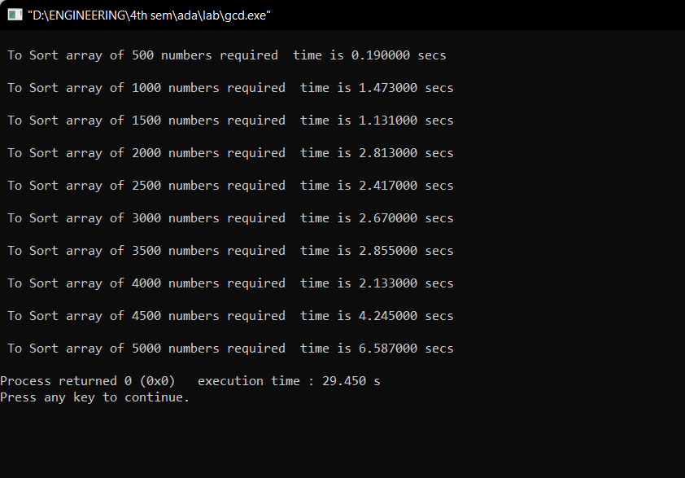

**GRAPH:**

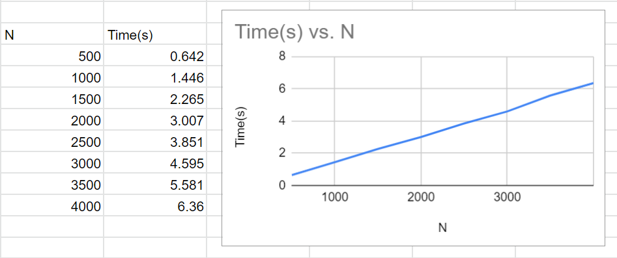

**9.Sort a given set of N integer elements using Quick Sort technique and compute its time taken.**

**CODE:**

**#include<stdio.h>**

**#include<time.h>**

**#include<math.h>**

**#include<stdlib.h>**

**void quicksort(int number[5000],int first,int last)**

**{**

**int i, j, pivot, temp;**

**if(first<last)**

**{**

**pivot=first;**

**i=first;**

**j=last;**

**while(i<j)**

**{**

**for(int x=0;x<10000000;x++);**

**while(number[i]<=number[pivot]&&i<last)**

**i++;**

**while(number[j]>number[pivot])**

**j--;**

**if(i<j)**

**{**

**temp=number[i];**

**number[i]=number[j];**

**number[j]=temp;**

**}**

**}**

**temp=number[pivot];**

**number[pivot]=number[j];**

**number[j]=temp;**

**quicksort(number,first,j-1);**

**quicksort(number,j+1,last);**

**}**

**}**

**int main()**

**{**

**clock_t start,end;**

**int i, count, number[5000];**

**printf("No. of elements: ");**

**scanf("%d",&count);**

**printf("Enter %d elements: ", count);**

**for(i=0;i<count;i++)**

**{**

**number[i]=rand()%5000;**

**}**

**start = clock();**

**quicksort(number,0,count-1);**

**end = clock();**

**printf("Order of Sorted elements: ");**

**for(i=0;i<count;i++)**

**{**

**printf(" %d",number[i]);**

**}**

**printf("\nSeconds taken %lf",(double)(end-start)/CLOCKS_PER_SEC);**

**return 0;**

**}**

**OUTPUT:**

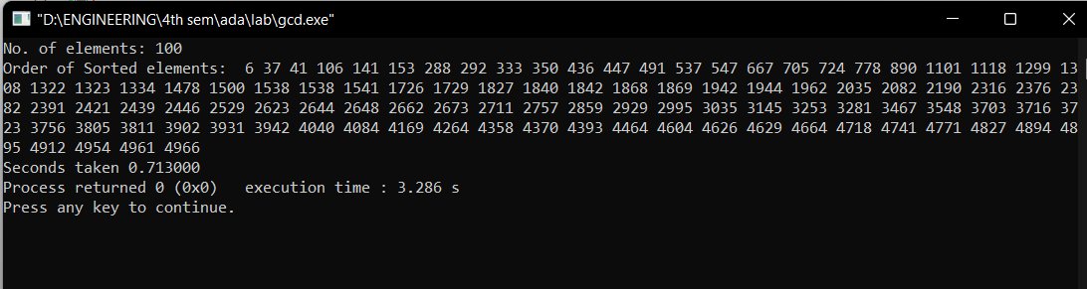

**GRAPH:**

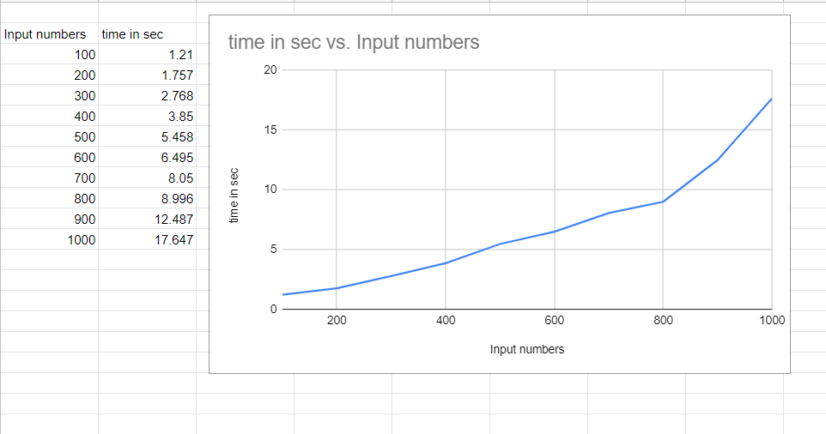

**10.Sort a given set of N integer elements using Heap Sort technique and compute its time taken.**

**#include<stdio.h>**

**#include<time.h>**

**void delay()**

**{**

**int k;**

**for(k=0;k<5000000;k++)**

**{}**

**}**

**void swap(int* a, int* b)**

**{**

**int temp = *a;**

**\*a = *b;**

**\*b = temp;**

**}**

**void heapify(int arr[], int N, int i)**

**{**

**int largest = i;**

**int left = 2 * i + 1;**

**int right = 2 * i + 2;**

**if (left < N && arr[left] > arr[largest])**

**largest = left;**

**if (right < N && arr[right] > arr[largest])**

**largest = right;**

**if (largest != i) {**

**swap(&arr[i], &arr[largest]);**

**heapify(arr, N, largest);**

**}**

**}**

**void heapSort(int arr[], int N)**

**{**

**delay();**

**int i;**

**for (i = N / 2 - 1; i >= 0; i--)**

**heapify(arr, N, i);**

**for (i = N - 1; i >= 0; i--) {**

**swap(&arr[0], &arr[i]);**

**heapify(arr, i, 0);**

**}**

**}**

**void printArray(int arr[], int N)**

**{**

**int i;**

**for (i = 0; i < N; i++)**

**printf("%d ", arr[i]);**

**printf("\n");**

**}**

**void main()**

**{**

**int n,i,arr[1000],num;**

**clock_t start,end;**

**printf("enter the number of integers");**

**scanf("%d",&n);**

**for(i=1;i<=n;i++)**

**{**

**num = (rand() % n) + 1;**

**arr[i-1] = num;**

**}**

**for(i=0;i<n;i++)**

**printf(" %d",arr[i]);**

**start=clock();**

**heapSort(arr, n);**

**end=clock();**

**printf("Sorted array is\n");**

**printArray(arr, n);**

**printf("time taken for %d values is %f",n,((double)(end-start)/CLOCKS_PER_SEC));**

**}**

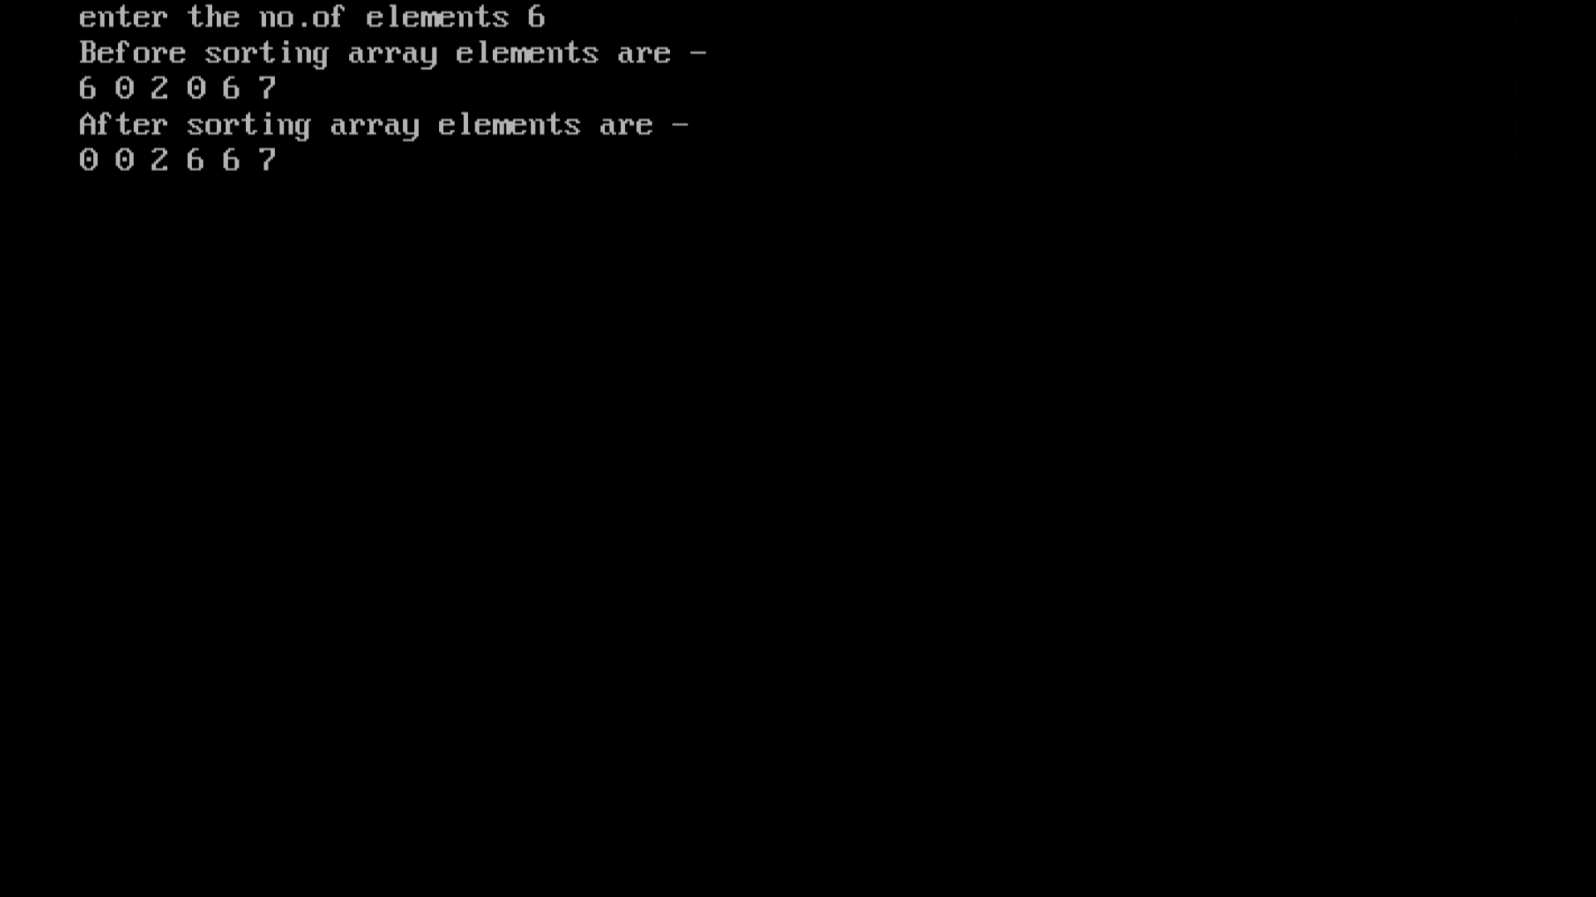

**11.Implement Warshall’s algorithm using dynamic programming**

**#include<stdio.h>**

**#include<math.h>**

**int max(int,int);**

**void warshall(int A[10][10],int n) {**

**int i,j,k;**

**for ( k=0;k<n;k++)**

**for ( i=0;i<n;i++)**

**for ( j=0;j<n;j++)**

**A[i][j]=max(A[i][j],A[i][k]&&A[k][j]);**

**}**

**int max(int a,int b) {**

**return a>b?a:b;**

**}**

**void main() {**

**int p[10][10];**

**int n;**

**int i,j;**

**printf("\n Enter the Number of Vertices : ");**

**scanf("%d",&n);**

**printf("\n Enter the adjacency matrix:\n");**

**for( i=0;i<n;i++)**

**{**

**for( j=0;j<n;j++)**

**scanf("%d",&p[i][j]);**

**}**

**printf("\n Matrix of input data: \n");**

**for ( i=0;i<n;i++) {**

**for ( j=0;j<n;j++)**

**printf(" %d\t",p[i][j]);**

**printf("\n");**

**}**

**warshall(p,n);**

**printf("\n Transitive closure: \n");**

**for ( i=0;i<n;i++) {**

**for ( j=0;j<n;j++)**

**printf(" %d\t",p[i][j]);**

**printf("\n");**

**}**

**}**

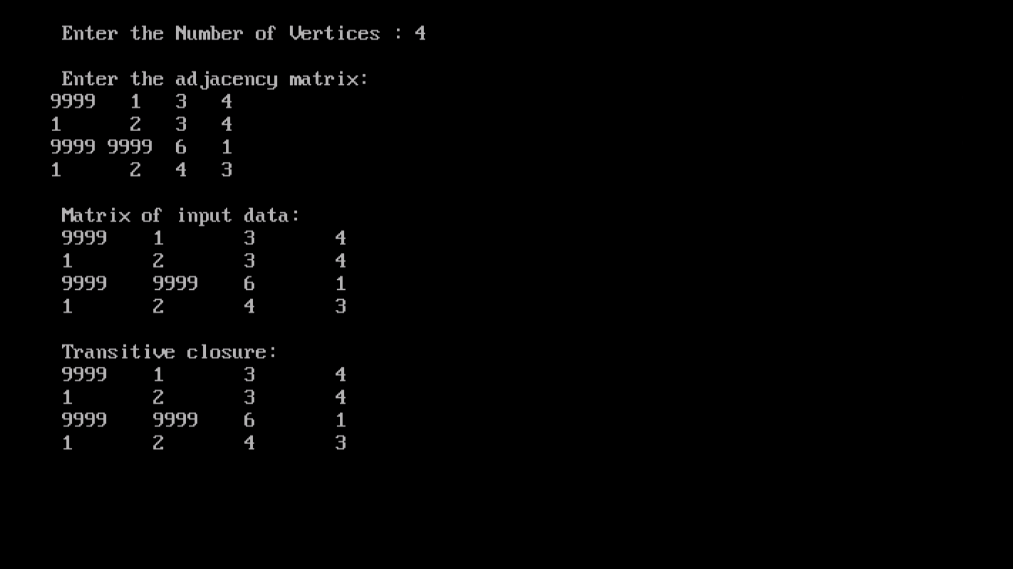

**12.Implement 0/1 Knapsack problem using dynamic programming.**

**CODE:**

**#include<stdio.h>**

**#include<conio.h>**

**void knapsack();**

**int max(int,int);**

**int i,j,n,m,p[10],w[10],v[10][10];**

**void main()**

**{**

**printf("\nenter the no. of items:\t");**

**scanf("%d",&n);**

**printf("\nenter the weight of the each item:\n");**

**for(i=1;i<=n;i++)**

**{**

**scanf("%d",&w[i]);**

**}**

**printf("\nenter the profit of each item:\n");**

**for(i=1;i<=n;i++)**

**{**

**scanf("%d",&p[i]);**

**}**

**printf("\nenter the knapsack's capacity:\t");**

**scanf("%d",&m);**

**knapsack();**

**getch();**

**}**

**void knapsack()**

**{**

**int x[10];**

**for(i=0;i<=n;i++)**

**{**

**for(j=0;j<=m;j++)**

**{**

**if(i==0||j==0)**

**{**

**v[i][j]=0;**

**}**

**else if(j-w[i]<0)**

**{**

**v[i][j]=v[i-1][j];**

**}**

**else**

**{**

**v[i][j]=max(v[i-1][j],v[i-1][j-w[i]]+p[i]);**

**}**

**}**

**}**

**printf("\nthe output is:\n");**

**for(i=0;i<=n;i++)**

**{**

**for(j=0;j<=m;j++)**

**{**

**printf("%d\t",v[i][j]);**

**}**

**printf("\n\n");**

**}**

**printf("\nthe optimal solution is %d",v[n][m]);**

**printf("\nthe solution vector is:\n");**

**for(i=n;i>=1;i--)**

**{**

**if(v[i][m]!=v[i-1][m])**

**{**

**x[i]=1;**

**m=m-w[i];**

**}**

**else**

**{**

**x[i]=0;**

**}**

**}**

**for(i=1;i<=n;i++)**

**{**

**printf("%d\t",x[i]);**

**}**

**}**

**int max(int x,int y)**

**{**

**if(x>y)**

**{**

**return x;**

**}**

**else**

**{**

**return y;**

**}**

**}**

**OUTPUT:**

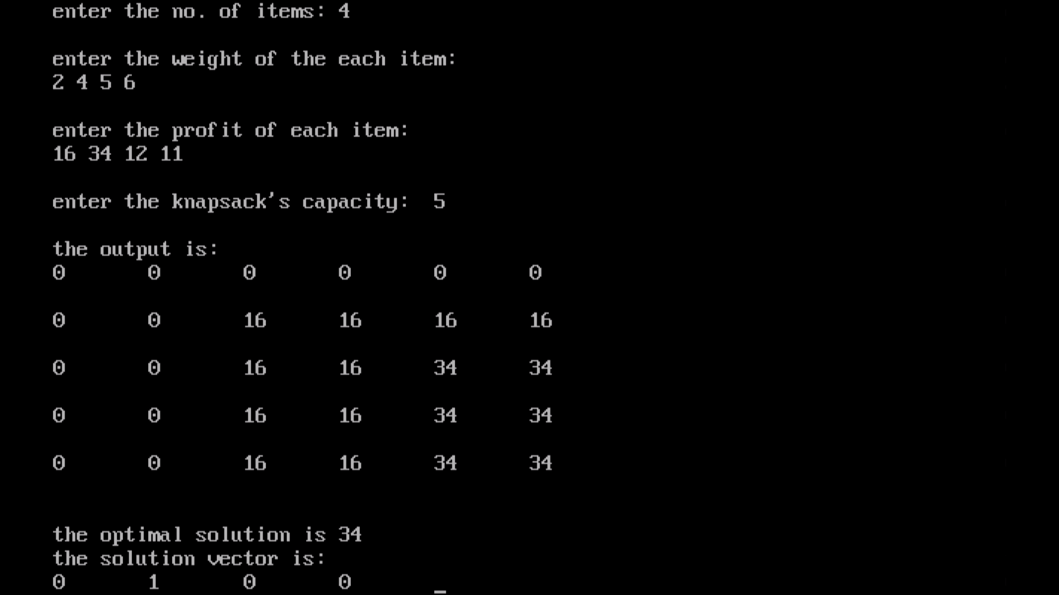

**13.Implement All Pair Shortest paths problem using Floyd’s algorithm.**

**CODE:**

**#include<stdio.h>**

**#include<conio.h>**

**int a[10][10],n;**

**void floyds();**

**int min(int,int);**

**void main()**

**{**

**int i,j;**

**printf("\nenter the no. of vertices:\t");**

**scanf("%d",&n);**

**printf("\nenter the cost matrix:\n");**

**for(i=1;i<=n;i++)**

**{**

**for(j=1;j<=n;j++)**

**{**

**scanf("%d",&a[i][j]);**

**}**

**}**

**floyds();**

**getch();**

**}**

**void floyds()**

**{**

**int i,j,k;**

**for(k=1;k<=n;k++)**

**{**

**for(i=1;i<=n;i++)**

**{**

**for(j=1;j<=n;j++)**

**{**

**a[i][j]=min(a[i][j],a[i][k]+a[k][j]);**

**}**

**}**

**}**

**printf("\nall pair shortest path matrix is:\n");**

**for(i=1;i<=n;i++)**

**{**

**for(j=1;j<=n;j++)**

**{**

**printf("%d\t",a[i][j]);**

**}**

**printf("\n\n");**

**}**

**}**

**int min(int x,int y)**

**{**

**if(x<y)**

**{**

**return x;**

**}**

**else**

**{**

**return y;**

**}**

**}**

**OUTPUT:**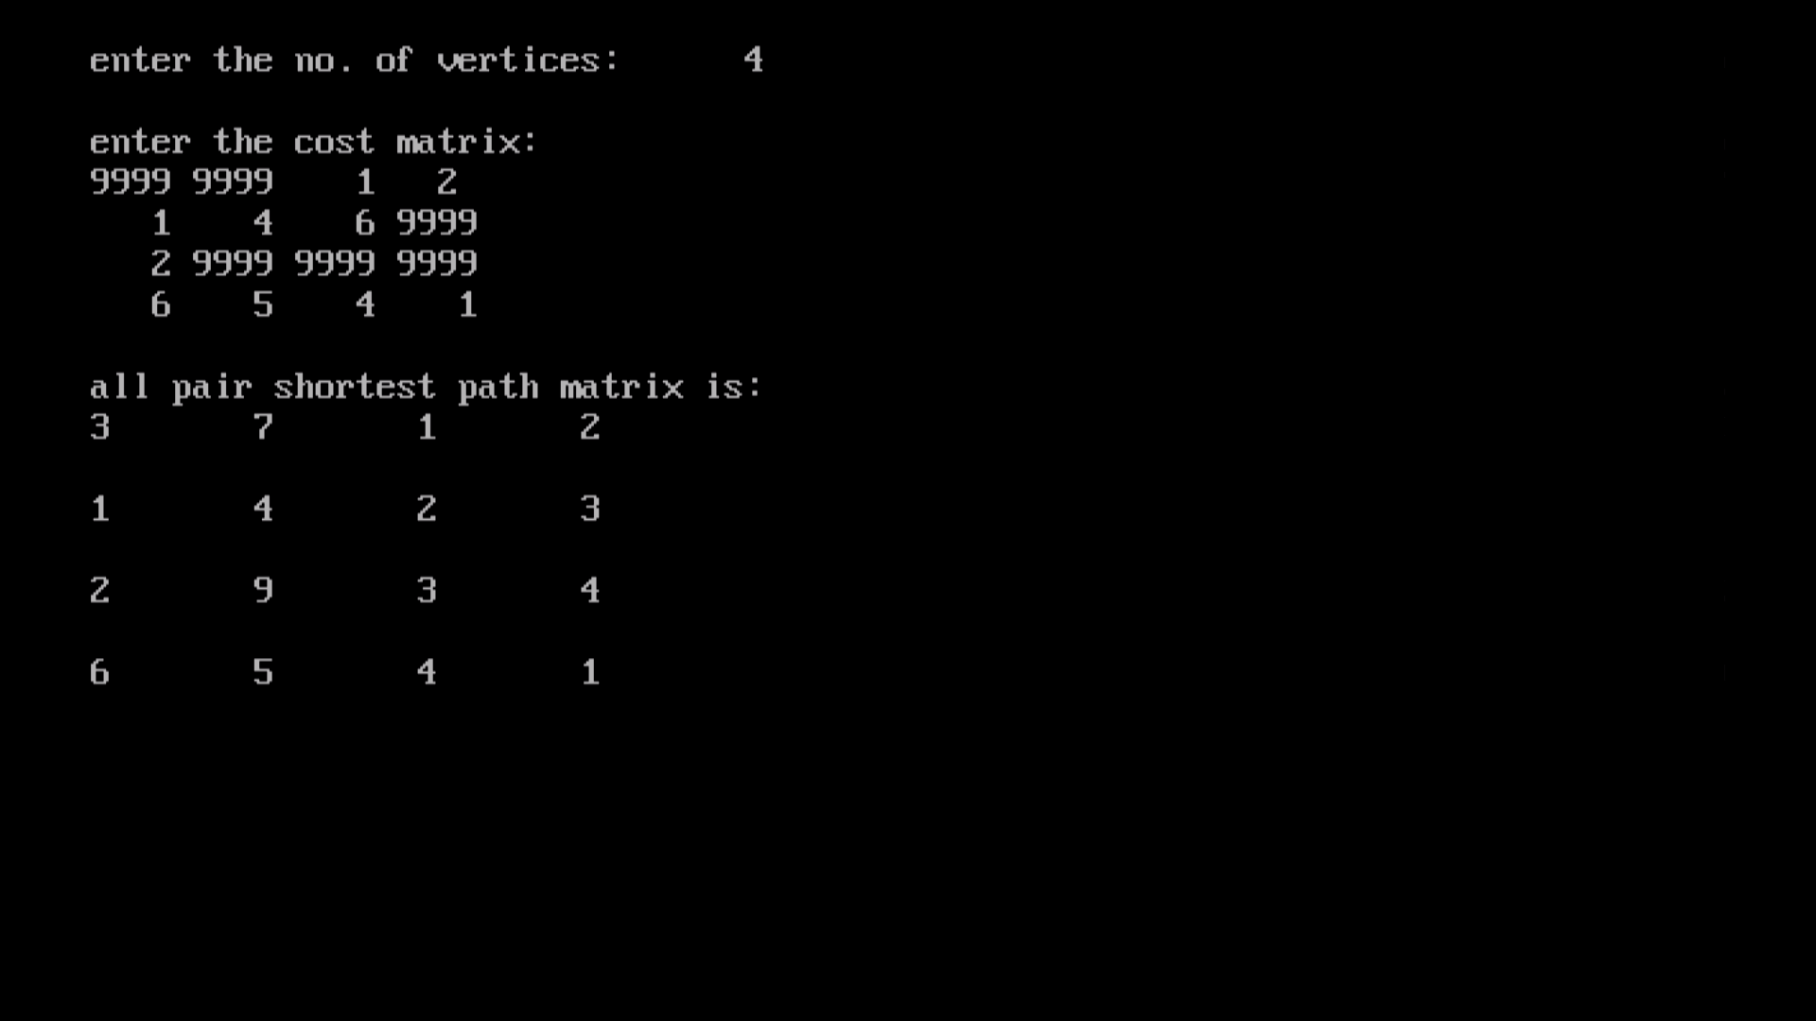

**14.Find Minimum Cost Spanning Tree of a given undirected graph using Prim’s algorithm.**

**CODE:**

**#include<stdio.h>**

**#include<conio.h>**

**#include<process.h>**

**void prims();**

**int c[10][10],n;**

**void main()**

**{**

**int i,j;**

**clrscr();**

**printf("\nenter the no. of vertices:\t");**

**scanf("%d",&n);**

**printf("\nenter the cost matrix:\n");**

**for(i=1;i<=n;i++)**

**{**

**for(j=1;j<=n;j++)**

**{**

**scanf("%d",&c[i][j]);**

**}**

**}**

**prims();**

**getch();**

**}**

**void prims()**

**{**

**int i,j,u,v,min;**

**int ne=0,mincost=0;**

**int elec[10];**

**for(i=1;i<=n;i++)**

**{**

**elec[i]=0;**

**}**

**elec[1]=1;**

**while(ne!=n-1)**

**{**

**min=9999;**

**for(i=1;i<=n;i++)**

**{**

**for(j=1;j<=n;j++)**

**{**

**if(elec[i]==1)**

**{**

**if(c[i][j]<min)**

**{**

**min=c[i][j];**

**u=i;**

**v=j;**

**}**

**}**

**}**

**}**

**if(elec[v]!=1)**

**{**

**printf("\n%d----->%d=%d\n",u,v,min);**

**elec[v]=1;**

**ne=ne+1;**

**mincost=mincost+min;**

**}**

**c[u][v]=c[v][u]=9999;**

**}**

**printf("\nmincost=%d",mincost);**

**}**

**OUTPUT:**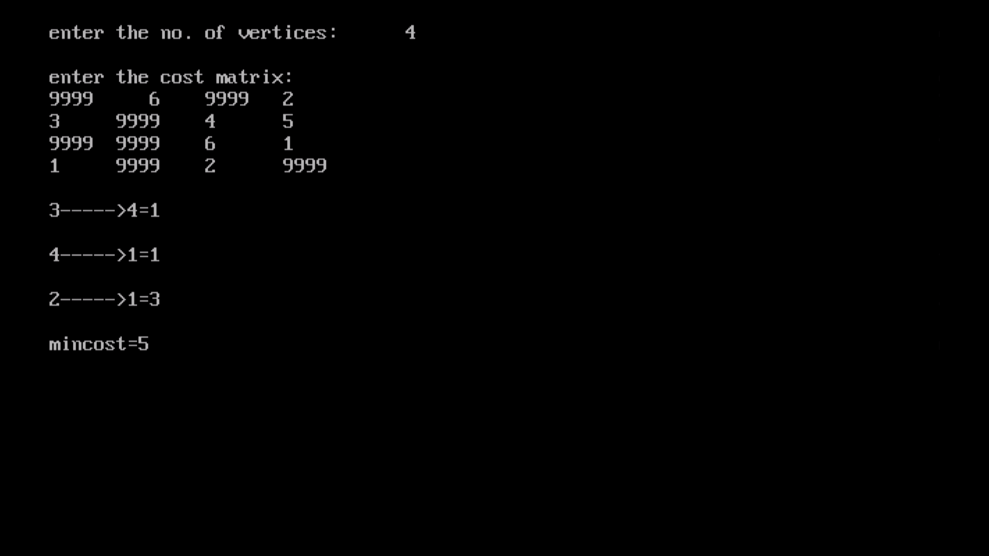

**15.Find Minimum Cost Spanning Tree of a given undirected graph using Kruskals algorithm.**

**CODE:**

**#include<stdio.h>**

**#include<conio.h>**

**void kruskals();**

**int c[10][10],n;**

**void main()**

**{**

**int i,j;**

**clrscr();**

**printf("\nenter the no. of vertices:\t");**

**scanf("%d",&n);**

**printf("\nenter the cost matrix:\n");**

**for(i=1;i<=n;i++)**

**{**

**for(j=1;j<=n;j++)**

**{**

**scanf("%d",&c[i][j]);**

**}**

**}**

**kruskals();**

**getch();**

**}**

**void kruskals()**

**{**

**int i,j,u,v,a,b,min;**

**int ne=0,mincost=0;**

**int parent[10];**

**for(i=1;i<=n;i++)**

**{**

**parent[i]=0;**

**}**

**while(ne!=n-1)**

**{**

**min=9999;**

**for(i=1;i<=n;i++)**

**{**

**for(j=1;j<=n;j++)**

**{**

**if(c[i][j]<min)**

**{**

**min=c[i][j];**

**u=a=i;**

**v=b=j;**

**}**

**}**

**}**

**while(parent[u]!=0)**

**{**

**u=parent[u];**

**}**

**while(parent[v]!=0)**

**{**

**v=parent[v];**

**}**

**if(u!=v)**

**{**

**printf("\n%d----->%d=%d\n",a,b,min);**

**parent[v]=u;**

**ne=ne+1;**

**mincost=mincost+min;**

**}**

**c[a][b]=c[b][a]=9999;**

**}**

**printf("\nmincost=%d",mincost);**

**}**

**OUTPUT:**



**16.From a given vertex in a weighted connected graph, find shortest paths to other vertices using Dijkstra’s algorithm.**

**CODE:**

**#include<stdio.h>**

**#include<conio.h>**

**void dijkstras();**

**int c[10][10],n,src;**

**void main()**

**{**

**int i,j;**

**clrscr();**

**printf("\nenter the no of vertices:\t");**

**scanf("%d",&n);**

**printf("\nenter the cost matrix:\n");**

**for(i=1;i<=n;i++)**

**{**

**for(j=1;j<=n;j++)**

**{**

**scanf("%d",&c[i][j]);**

**}**

**}**

**printf("\nenter the source node:\t");**

**scanf("%d",&src);**

**dijkstras();**

**getch();**

**}**

**void dijkstras()**

**{**

**int vis[10],dist[10],u,j,count,min;**

**for(j=1;j<=n;j++)**

**{**

**dist[j]=c[src][j];**

**}**

**for(j=1;j<=n;j++)**

**{**

**vis[j]=0;**

**}**

**dist[src]=0;**

**vis[src]=1;**

**count=1;**

**while(count!=n)**

**{**

**min=9999;**

**for(j=1;j<=n;j++)**

**{**

**if(dist[j]<min&&vis[j]!=1)**

**{**

**min=dist[j];**

**u=j;**

**}**

**}**

**vis[u]=1;**

**count++;**

**for(j=1;j<=n;j++)**

**{**

**if(min+c[u][j]<dist[j]&&vis[j]!=1)**

**{**

**dist[j]=min+c[u][j];**

**}**

**}**

**}**

**printf("\nthe shortest distance is:\n");**

**for(j=1;j<=n;j++)**

**{**

**printf("\n%d----->%d=%d",src,j,dist[j]);**

**}**

**}**

**OUTPUT:**

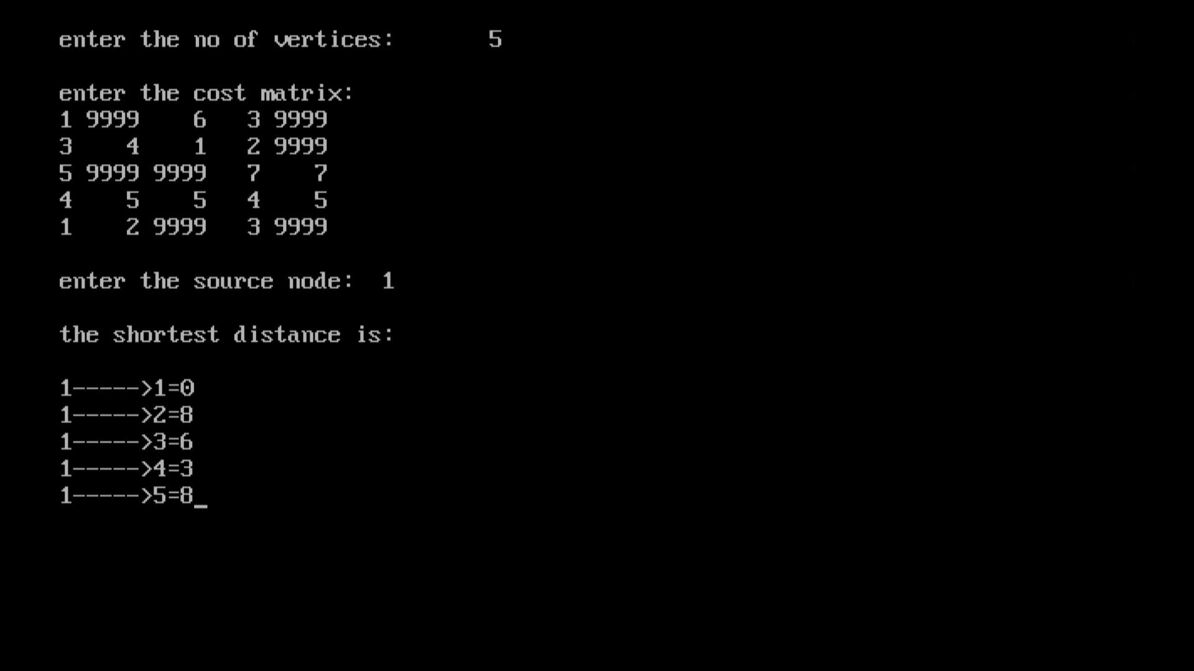

**17.Implement “Sum of Subsets” using Backtracking. “Sum of Subsets”problem: Find a subset of a given set S = {s1,s2,……,sn} of n positive integers whose sum is equal to a given positive integer d. For example, if S = {1,2,5,6,8} and d = 9 there are two solutions {1,2,6} and {1,8}. A suitable message is to be displayed if the given problem instance doesn’t have a solution.**

**CODE:**

**#include<stdio.h>**

**#include<conio.h>**

**intcount,w[10],d,x[10];**

**void subset(int cs, int k, int r)**

**{**

**int i;**

**x[k]=1;**

**if(cs+w[k]==d)**

**{**

**printf("\nSubset solution = %d\n", ++count);**

**for(i=0;i<=k;i++)**

**{**

**if(x[i]==1)**

**printf("%d", w[i]);**

**}**

**}**

**else**

**if(cs+w[k]+w[k+1]<=d)**

**subset(cs+w[k], k+1, r-w[k]);**

**if((cs+r-w[k]>=d) && (cs+w[k+1])<=d)**

**{**

**x[k]=0;**

**subset(cs,k+1,r-w[k]);**

**}**

**}**

**void main()**

**{**

**int sum=0,i,n;**

**printf("Enter the number of elements\n");**

**scanf("%d", &n);**

**printf("Enter the elements in ascending order\n");**

**for(i=0;i<n;i++)**

**scanf("%d", &w[i]);**

**printf("Enter the required sum\n");**

**scanf("%d", &d);**

**for(i=0;i<n;i++)**

**sum+=w[i];**

**if(sum<d)**

**{**

**printf("No solution exists\n");**

**return;**

**}**

**printf("The solution is\n");**

**count=0;**

**subset(0,0,sum);**

**getch();**

**}**

**OUTPUT:**

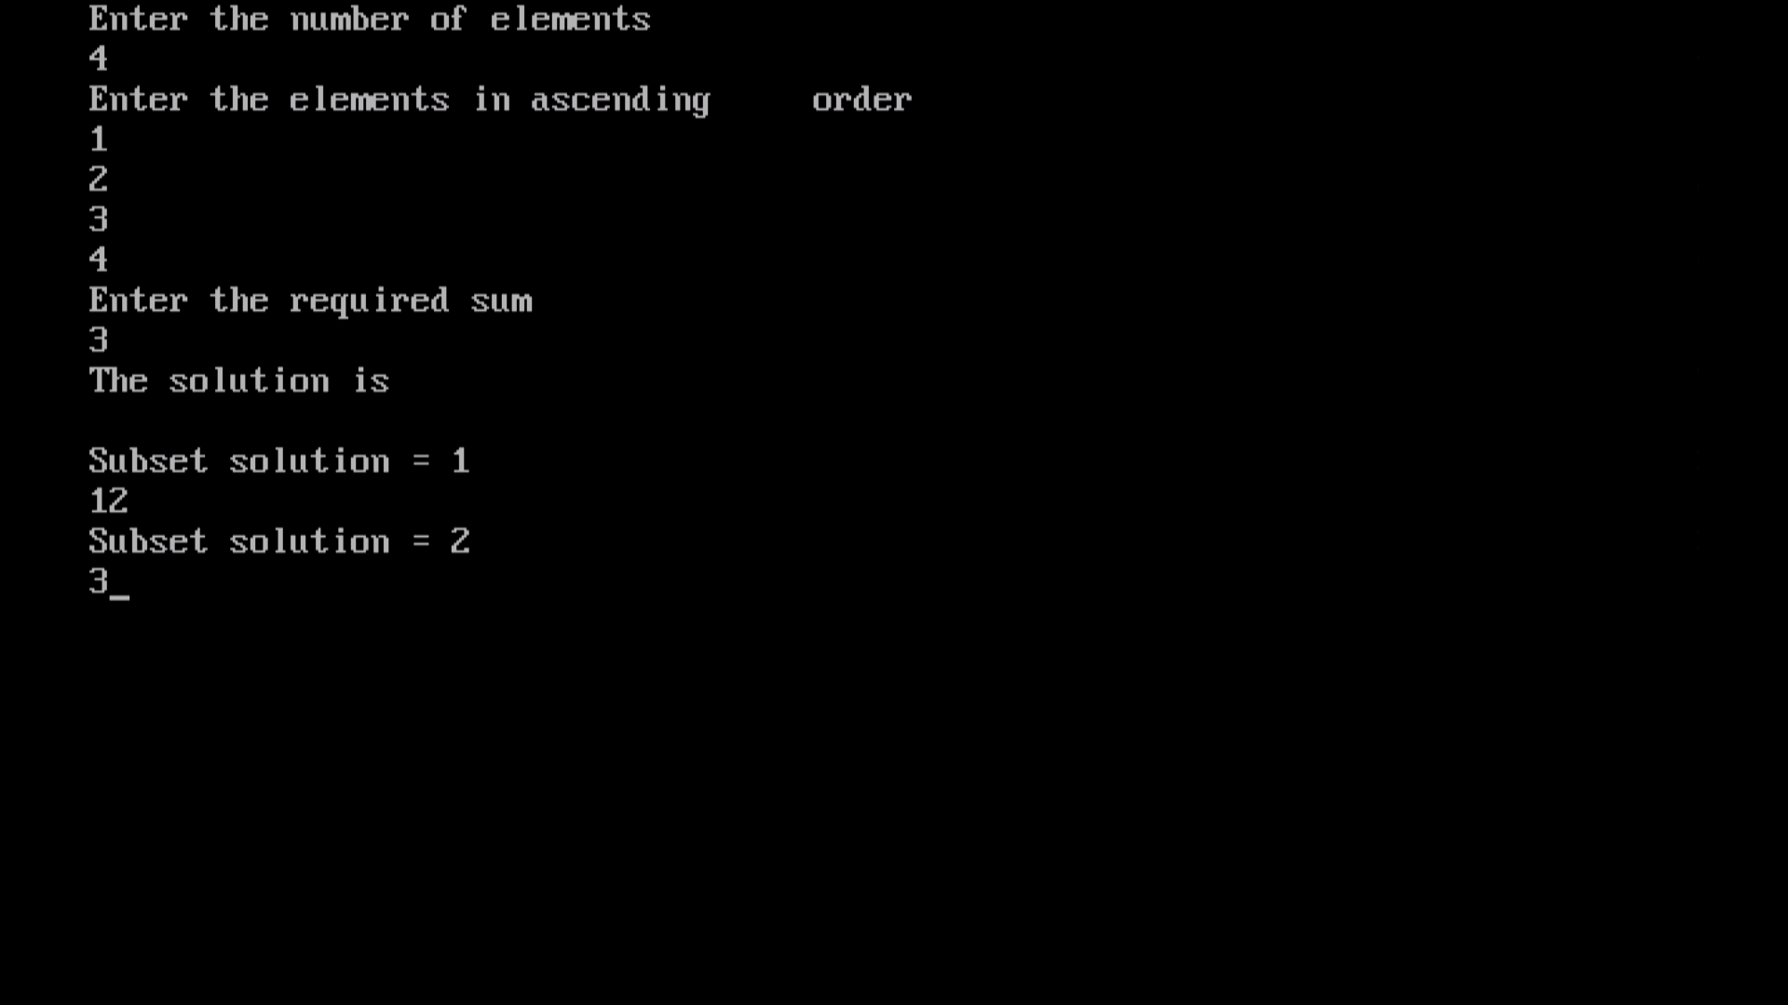

**18.Implement “N-Queens Problem” using Backtracking.**

**CODE:**

**#include<stdio.h>**

**#include<conio.h>**

**void nqueens(int n)**

**{**

**Int k,x[20],count=0;**

**k=1;**

**x[k]=0;**

**while(k!=0)**

**{**

**x[k]++;**

**while(place(x,k)!=1 && x[k]<=n)**

**x[k]++;**

**if(x[k]<=n)**

**{**

**if(k==n)**

**{**

**printf("\nSolution is %d\n", ++count);**

**printf("Queen\t\tPosition\n");**

**for(k=1;k<=n;k++)**

**printf("%d\t\t%d\n", k,x[k]);**

**}**

**else**

**{**

**k++;**

**x[k]=0;**

**}**

**}**

**else**

**k--;**

**}**

**}**

**int place(int x[], int k)**

**{**

**int i;**

**for(i=1;i<=k-1;i++)**

**{**

**if(i+x[i]==k+x[k]||i-x[i]==k-x[k]||x[i]==x[k])**

**return 0;**

**}**

**return 1;**

**}**

**void main()**

**{**

**int n;**

**clrscr();**

**printf("Enter the number of Queens\n");**

**scanf("%d", &n);**

**nqueens(n);**

**getch();**

**}**

**OUTPUT:**

